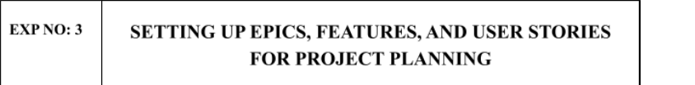

Aim:
To learn about how to create epics, user story, features, backlogs for your assigned project

FEATURES:
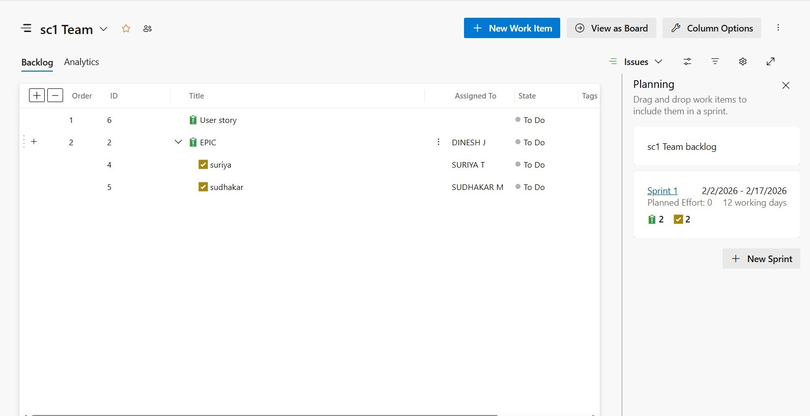

Result:
Thus, the creation of epics, features, user story and task has been created successfully

